Alireza Ebtehaj (ae256)

Prototype Description Document

1. Introduction

This Leeds website is a high-fidelity prototype for people living in Leeds and those visiting. It has a calendar where users can check which days are free to go out or do something in the city, a map that shows different types of places based on categories, and a search box that helps you find a location and see how far it is from where you are. It also includes a favourites feature so you can like an event and a place, and it will save them. You can see it by grid or on the map. My motivation behind this website was that I couldn't locate a website with all these features in one place, and as a tourist and local, it's good to have a website like this. The design is focused on what people need most: simple navigation, clear layout, quick access to saved places, and tools that help them plan without wasting time.

2. Prototype Functionality

One feature I added is the login and sign-up system. Users can make an account by filling out a form with their first name, last name, date of birth, email, and password. They also have to confirm their password. If the two passwords don’t match, the error is “Passwords do not match”. If they match, the user gets sent to the login page. From there, they can enter their email and password. If they type it in right, they’ll log in. If they don’t, the page shows an error message saying, “Invalid credentials!” so they know it’s incorrect.

The first advanced feature I worked on was the calendar. Users can interact with the calendar page by using three input fields. The first is a search box to help them find a specific event. The other two are for selecting a start date and an end date. They can pick a time range to see what events are happening during that period. If they choose a start date after the end date and press “Find Results,” the system shows an error message saying, “Start Date cannot be after End Date!”  
I also added filtering. Users can filter events by category using checkboxes, and they can also set a price range. If someone enters a minimum price higher than the maximum, the system shows another error: “Min price cannot be higher than Max price.” There’s a button to apply the filters, and it’s meant to remember what the user selected. Right now, though, the filter and search don’t work in the prototype because it would need a real database behind it to check event data and match results based on the filters.

The second advanced feature I worked on is the map. When you go to the map page, there’s a map you can interact with. On the left side, there’s a search box where you can type in the name of a place or event you’re looking for. Also, there is a list of categories like restaurants, parks, museums, and more. If you click one of those buttons, it will show a place from that category. The left panel shows more information about the place on the left of the screen, like the address, phone number, a photo, and a heart icon you can click to save it to your favourites. Because this is a prototype, selecting a category won’t show multiple pins on the map — it just shows one example pin to give the idea. In a full version with real data, clicking a category would display lots of places and pins from that category across the map. But for now, this version shows how it’s supposed to work.

The third feature I worked on was the save system. Users can click the heart button on any event or place they like. When they click it, the heart icon changes to show that it’s been saved. All the places they’ve liked get added to the favourites page. By default, the favourites are shown in a grid layout. There’s also a button that lets users switch to a map view. When they click that, it shows all the places they’ve saved on the map, so they can see where everything is and get a general idea of how far things are from each other. Click the heart button again to remove a place or event from your favourites.

3. Background Technologies

One of the CSS frameworks that I used was Bootstrap 5. It uses a responsive layout that automatically adjusts to fit different screen sizes, such as mobiles, tablets, and more. This way, I did not have to write custom media queries. If I wanted to add more styling, I could use CSS on top of it. The other thing I used was the Google Maps Embed API to display a map on my website. I added extra stuff to the map using JavaScript, like a category option and an information panel. I also used JavaScript on other pages. For example, when clicking the heart button, the display colour would change and be saved. I also used it to handle basic errors.

4. Annotated Screenshots

Figure . Homepage top section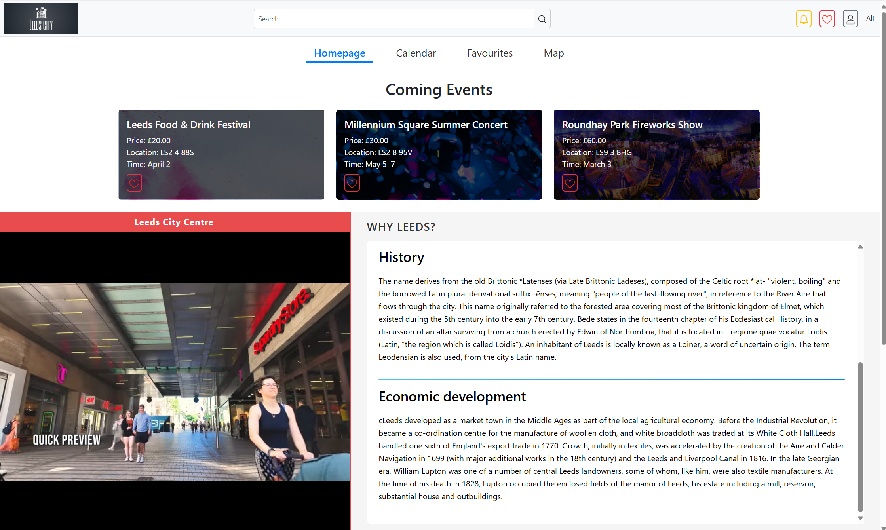

Figure . Homepage bottom section

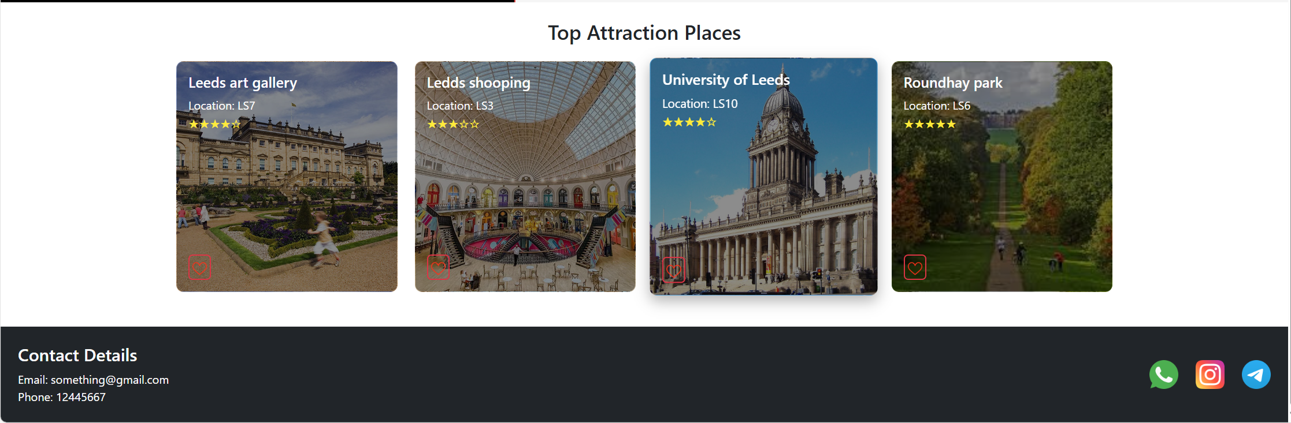

In Figure 1, we are on the homepage, shown by the navigation bar's underline. The header is at the top of the page and is used across all pages. It includes a top bar — from left to right, the Leeds logo, a global search box, a notification button, a heart button that takes the user to their favourites, the logout button, and the username, which here is “Ali”. Below that is the main navigation bar. Clicking any of the items takes you to a different website section. Under the nav bar, there’s a section that shows upcoming events, and below that is a video that auto-plays when you land on the page. There’s also a scrolling text section with animation — you need to scroll to read the whole message and continue exploring the site. In Figure 2, you can see the “Top Attraction Places” section and the footer. The footer appears on all pages and includes contact details on the left and social media links on the right. For accessibility, I made sure that the YouTube video starts muted, all icons and images (including the logo) have alt text, and the layout and colour choices were made to keep everything clear and easy to read.

Figure . Map page before selecting a category

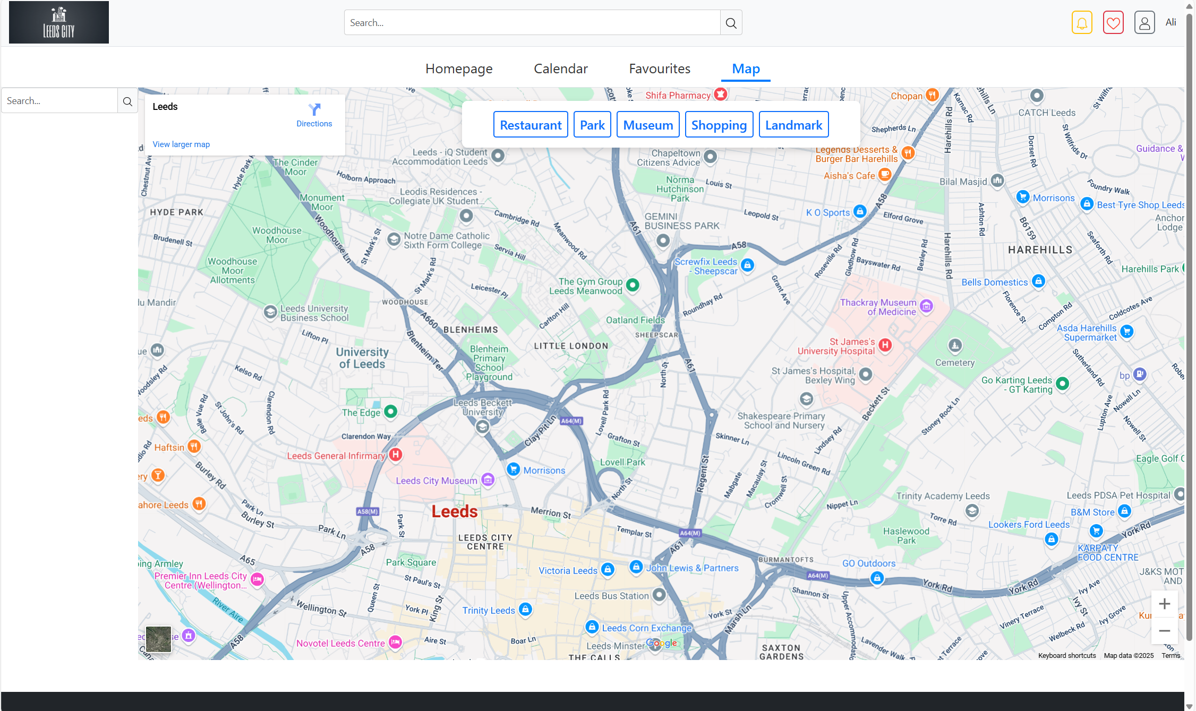

Figure . Map page after selecting a category screenshot

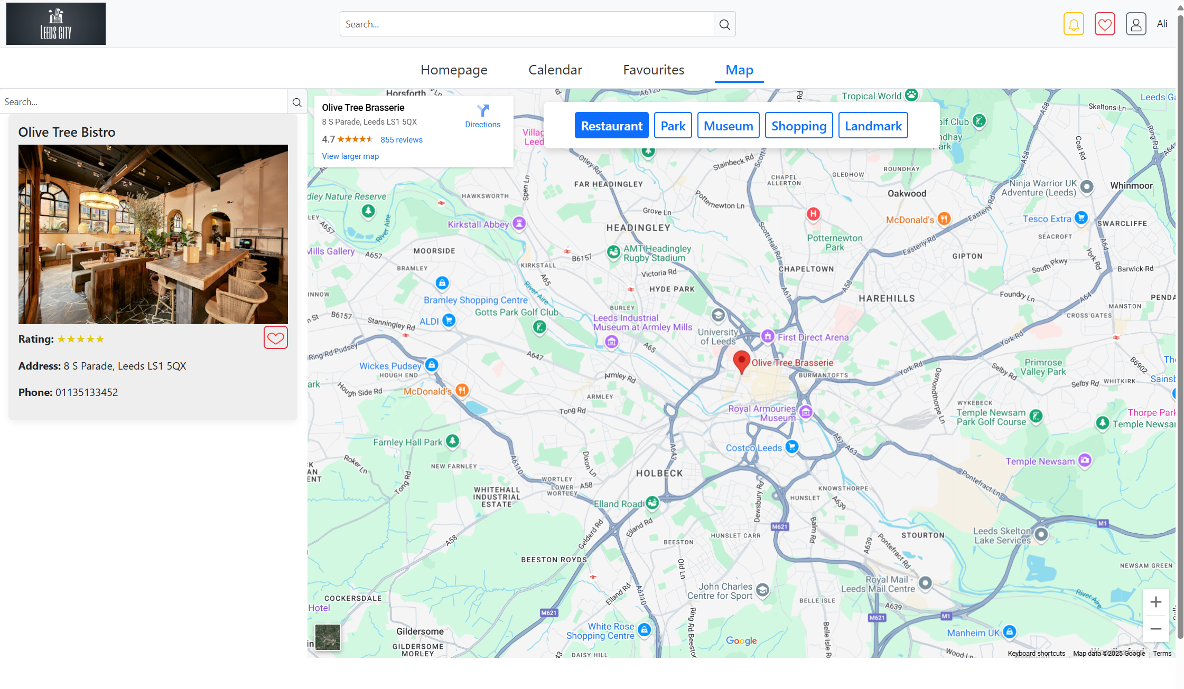

Figure 3 shows the map section. You can see a small underline under “Map” in the navigation bar, so the user knows they are on this page. This part of the site lets users explore Leeds using the map. They can search for a specific place or event using the search box on the top left of the map. Users can choose from popular categories like restaurants, parks, and more. Figure 4 shows what happens when someone clicks on “Restaurant” — it shows where that place is on the map, and the info panel pops up with the details. For accessibility, I ensured the buttons were big enough to click easily, the text was readable, and the layout was spaced out clearly, so it didn’t feel crowded.

Figure . Calendar page before interacting with the filter

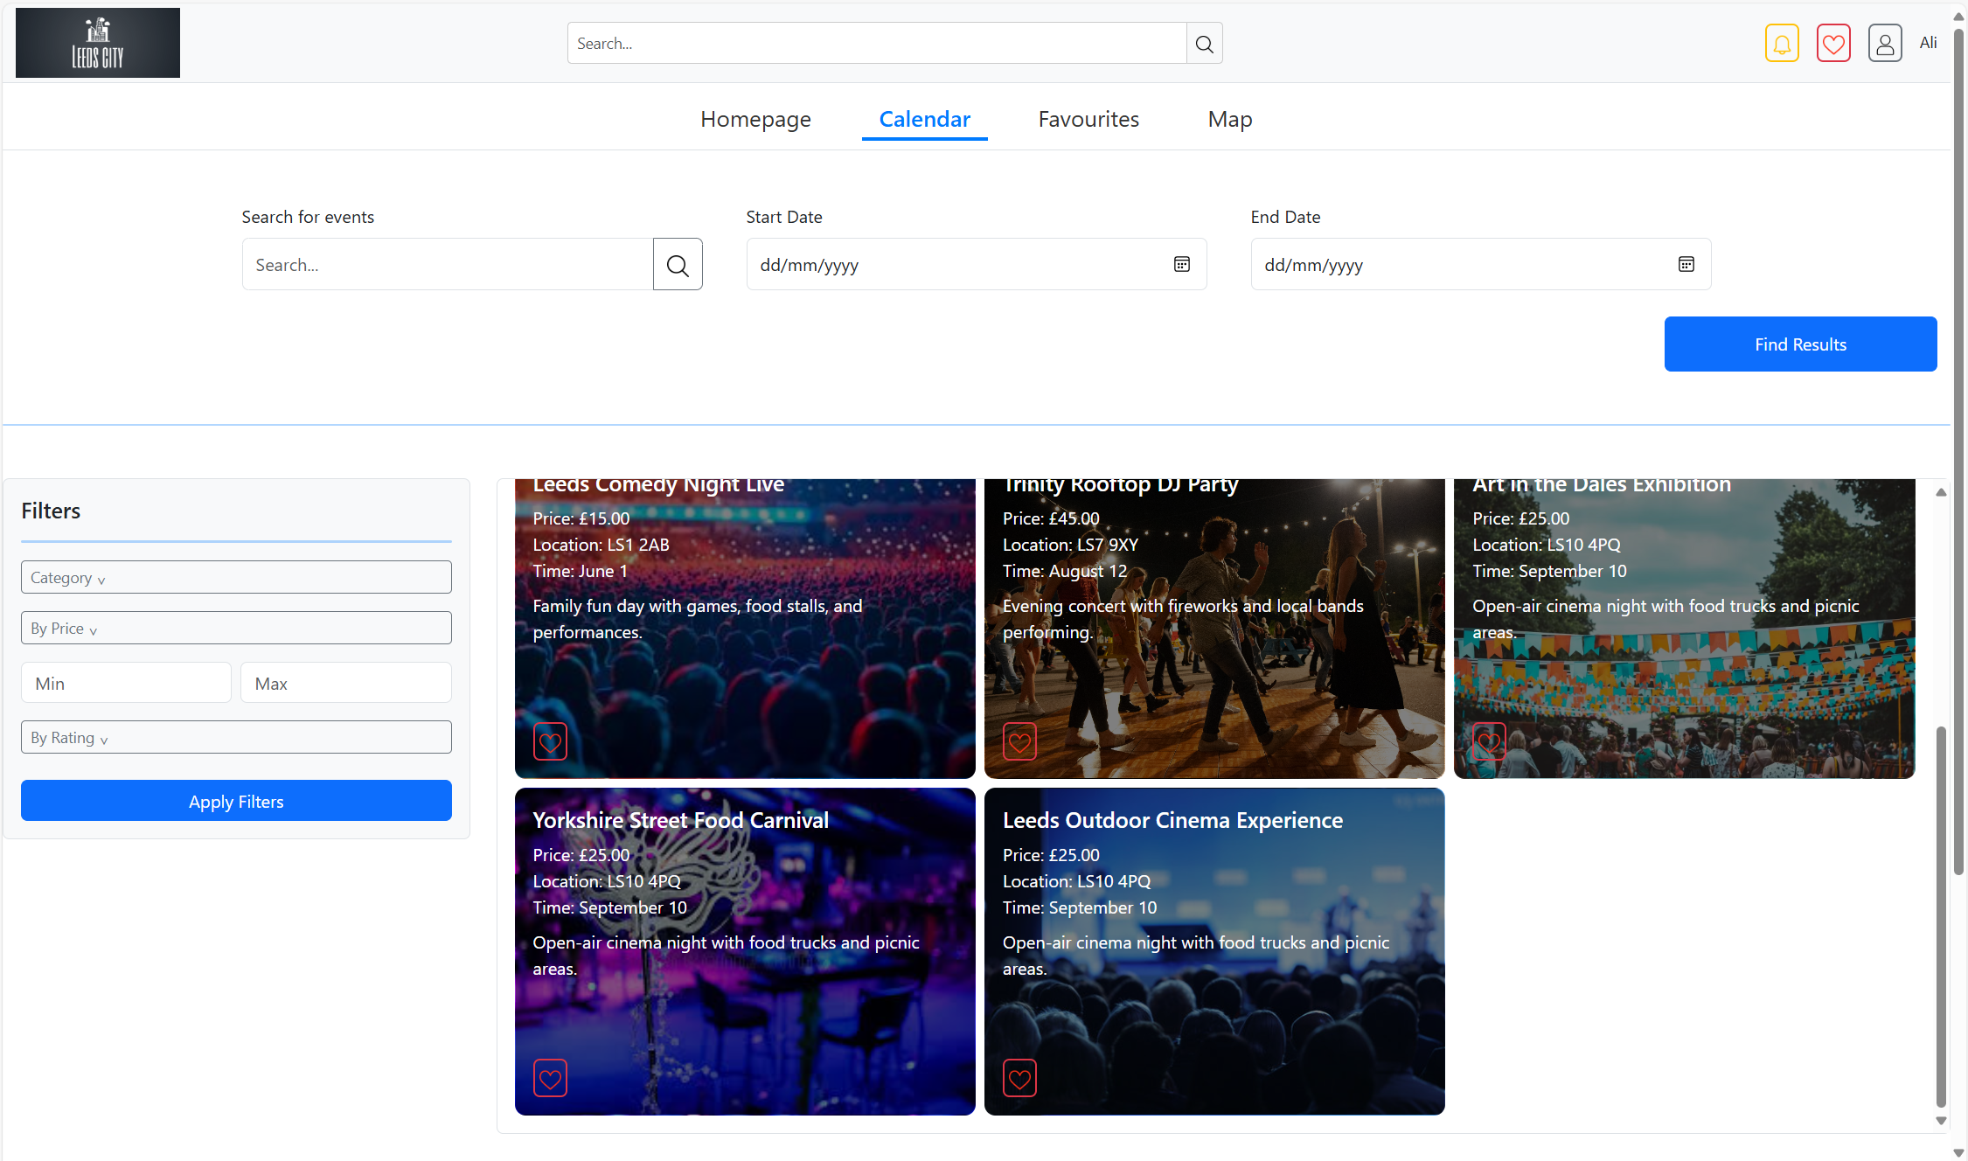

Figure . Calendar page after interacting with the filter

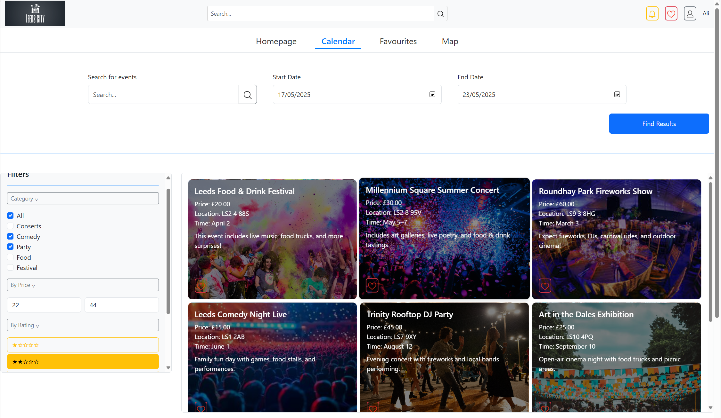

In Figure 5, the calendar page is shown by the underline under "Calendar" in the navigation bar. The user can search or choose a period using this page's start and end date inputs. After that, they can press the "Find Results" button to see events happening during that time. Under the input section is a list of events the user can scroll through. You can see category, price, and rating filter options on the left side. As shown in Figure 6, when the user clicks on one of those filter buttons, it expands to let them choose options and apply the filter. This page is accessibility friendly because all images for the heart button include alt text, and the layout is kept clean.

Figure Favourites page on the grid section

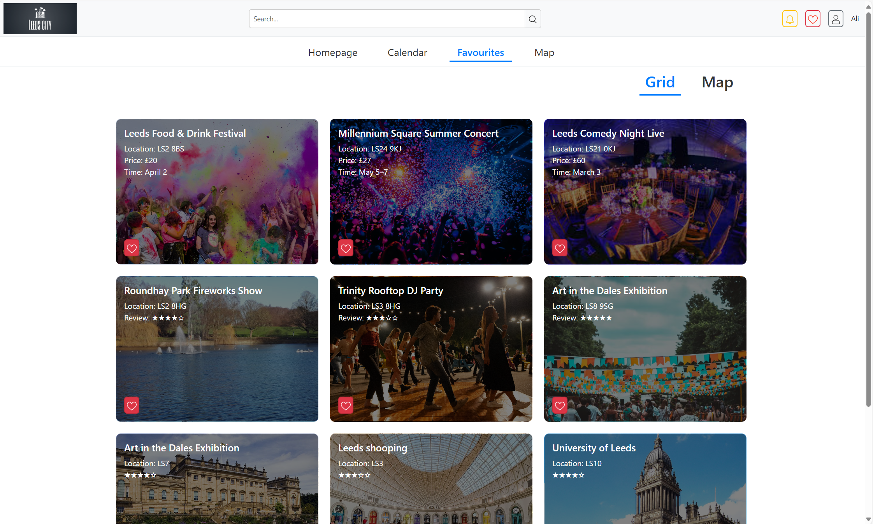

Figure Favourites page on the map section

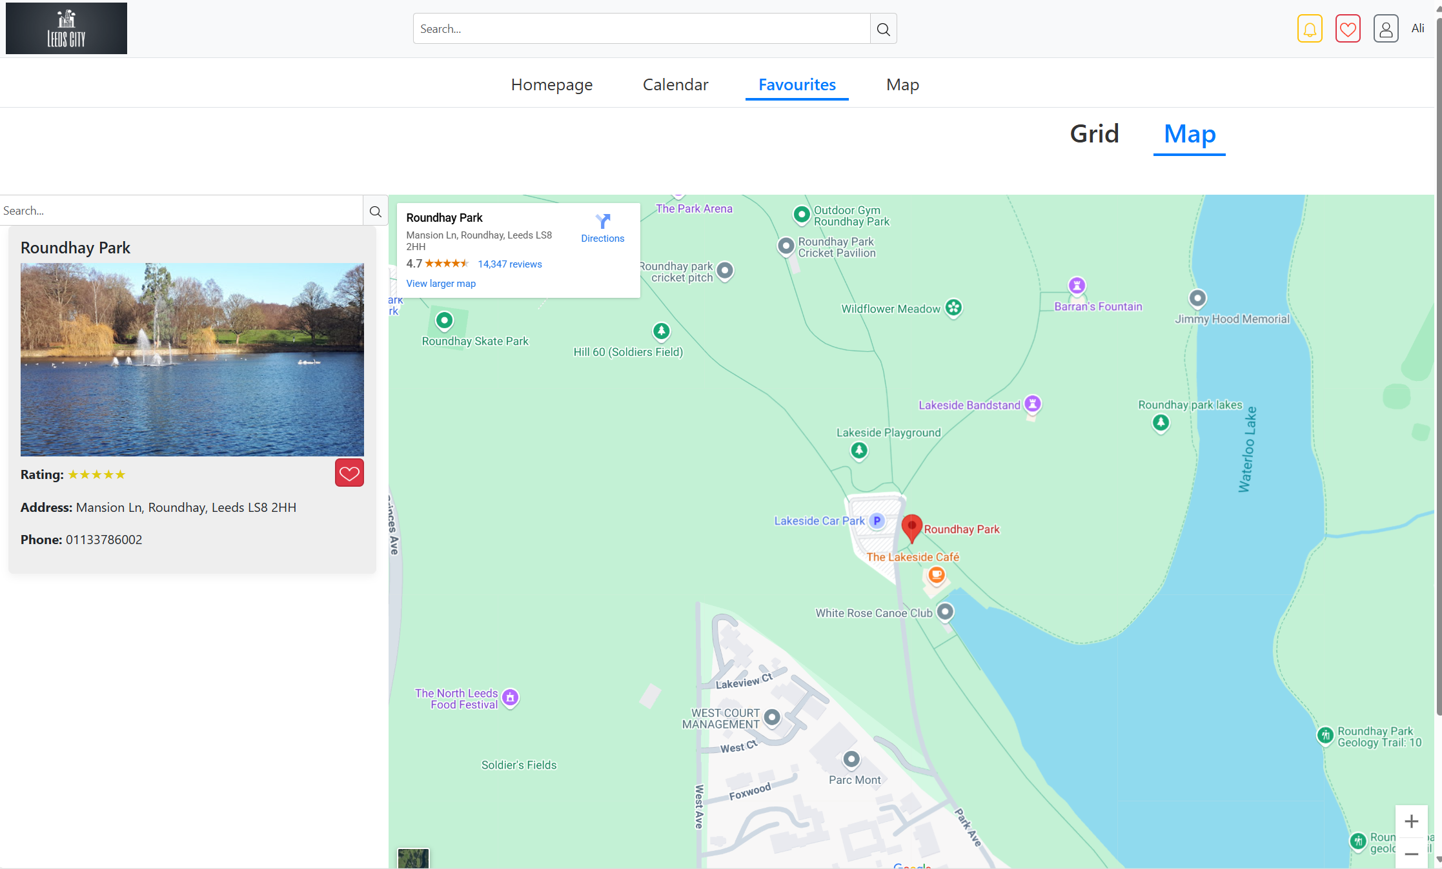

Figure 7 shows the Favourites page. You can tell you are on this page because of the underline in the navigation bar. The user can see all the places and events they have liked on this page. The item will be unavailable and removed from the list if they click the heart button again. Figure 8 shows what happens when the user clicks the "Map" button. This changes the view so the user can see all their saved places on the map. It helps them understand where everything is and how far places are from each other.

5. Heuristic Evaluation & Usability Testing

Usability Testing:

These tests were done using a [Google Form](https://docs.google.com/forms/d/e/1FAIpQLSckNA0zd8v79CD4PqHQS1XDO4fs0UWs6j8JXLhY24WRM2lXiw/viewform?usp=dialog), and seven people took part — mostly my classmates and some of my family members.

For the usability testing, I created five tasks for users to complete and asked them to answer questions based on each task. I gathered the results and created a table that shows a summary of the responses.

|  |  |  |  |
| --- | --- | --- | --- |
| Tasks | Completion | Ease Rating (1–5, where 1 = Difficult and 5 = Easy) | Comments |
| **Task 1: Map Interaction**  Navigate to the Map page, select a category (e.g., Restaurant), and observe the map and details displayed. | 7/7 users completed it | |  | | --- | | Average: 5.0 | | It's clear and easy to understand how it works.  Easy to use. |
| **Task 2: Invalid Date Selection**  Go to the Calendar page. Choose a start date that is later than the end date, then click Search to see if the system gives an error or warning. | 7/7 users completed it | Average: 5.0 | Everything worked well and is easy to understand |
| **Task 3: Filtering Interaction**  On the Calendar page, interact with the filter options. Try setting a minimum price higher than the maximum price, then click Search. See if the system gives errors. | 7/7 users completed it | Average: 5.0 | This works okay and the warning is shown. |

|  |  |  |  |
| --- | --- | --- | --- |
| **Task 4: Navigation**  **Use the top**  navigation bar to visit Homepage→ Calendar → Things to do→  Map . | 7/7 users completed it | Average: 4.86 | I didnt like when i press the things to do button on nav it didnt go to any page I preferred it went to things i liked |
| **Task 5: Login or Signup Untitled section**  Click the User Profile icon (top right of the page) and interact with the Login or Signup form, and do the Sing up form then logging, | 7/7 users completed it | Average: 4.86 | The Icon doesn't have a tooltip to help recognize that it's used for logging out. |

All the users could complete the tasks, showing that the system works as it should. Tasks 1 to 3 were easy for most people, and the average ease rating was 5.0. Tasks 4 and 5 had a slightly lower average of 4.86, but no one had trouble finishing them. Most of the feedback was positive, though a few people did suggest improvements, especially for Tasks 4 and 5. I investigated those and will discuss them in the feedback section. Below is a screenshot showing the responses I got for all the tasks during usability testing.

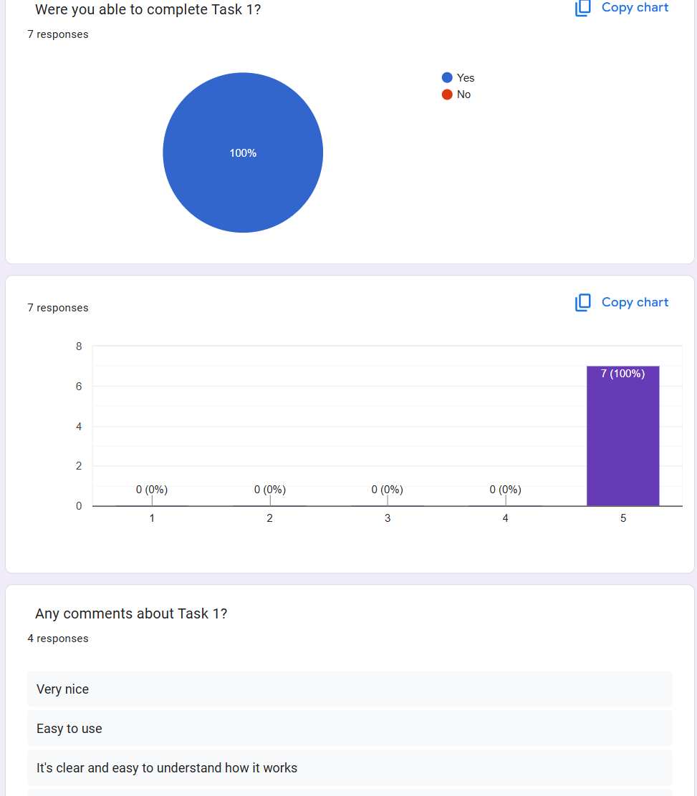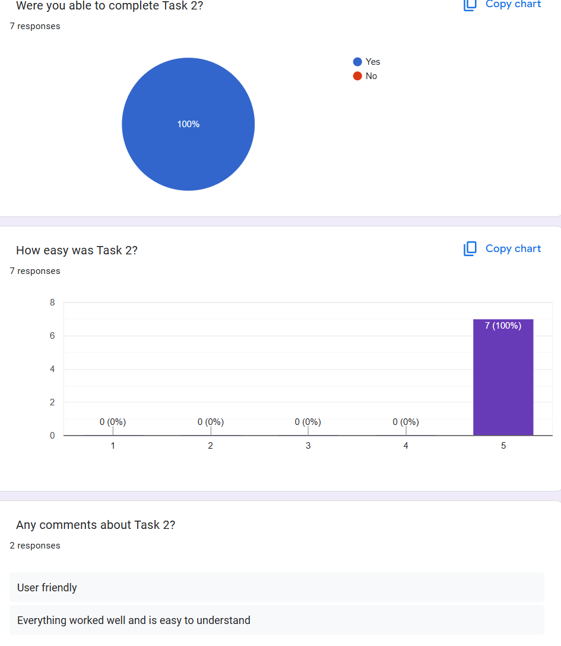

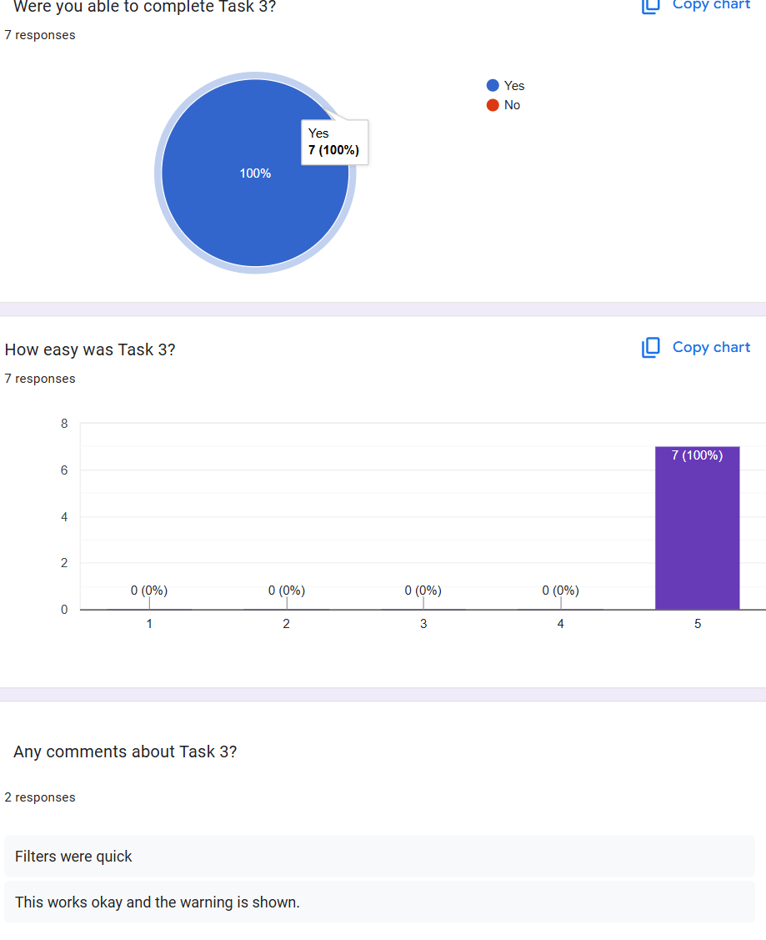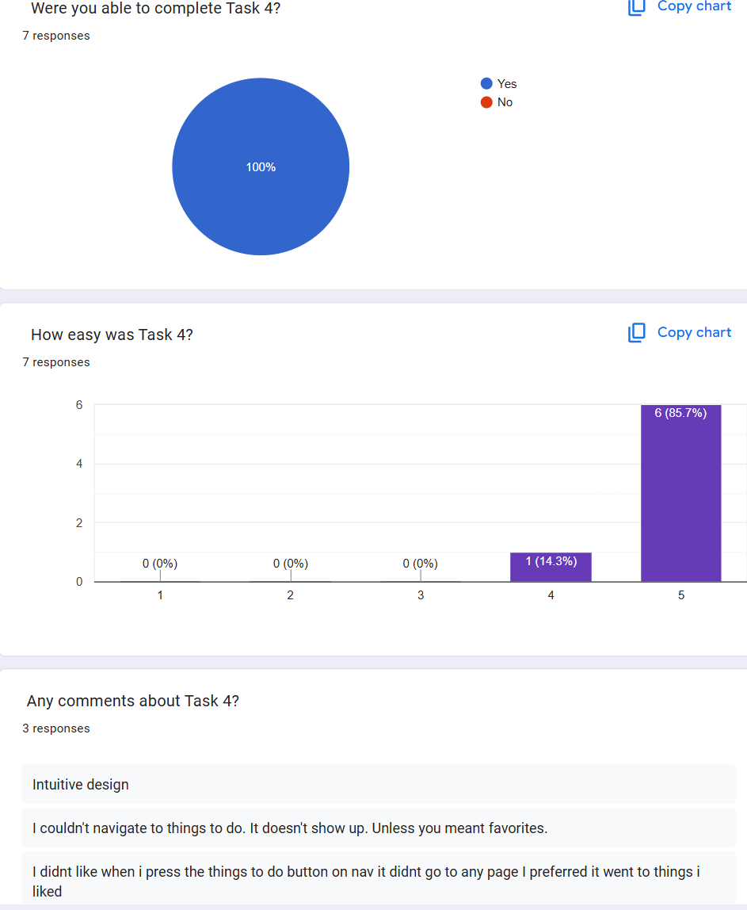

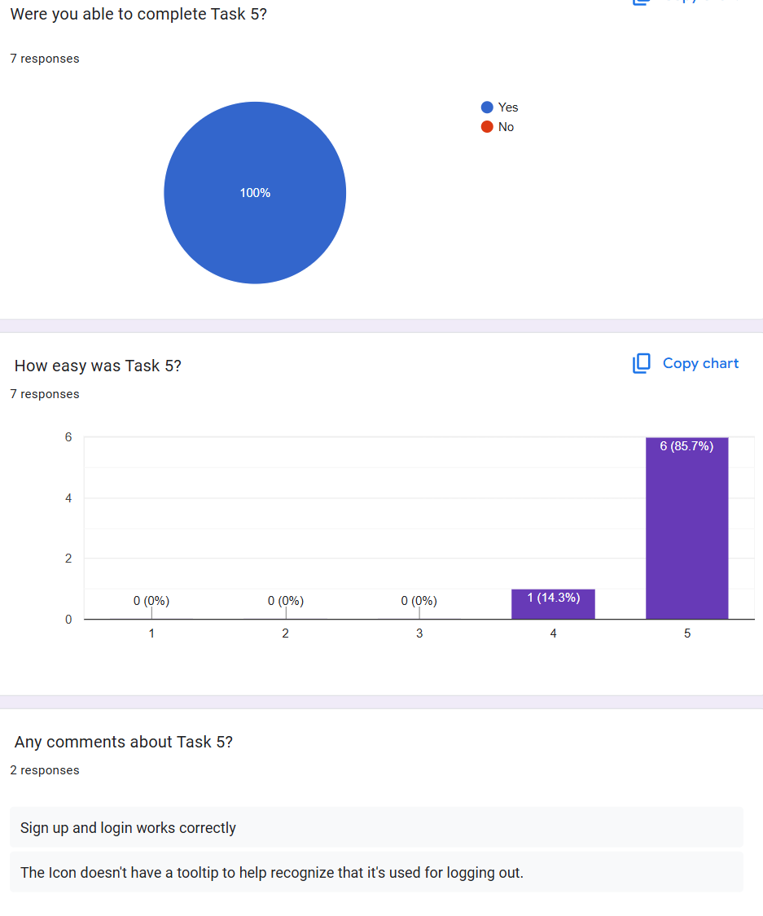

Heuristic Evaluation:

For heuristic evaluation, I tested all 10 of Nielsen’s heuristics. I asked seven users to review each one and rate how well the site followed it, using a scale from 0 to 4. 0 means no problem, and four is a Usability catastrophe. The questions and responses of the seven users are shown below.

Question

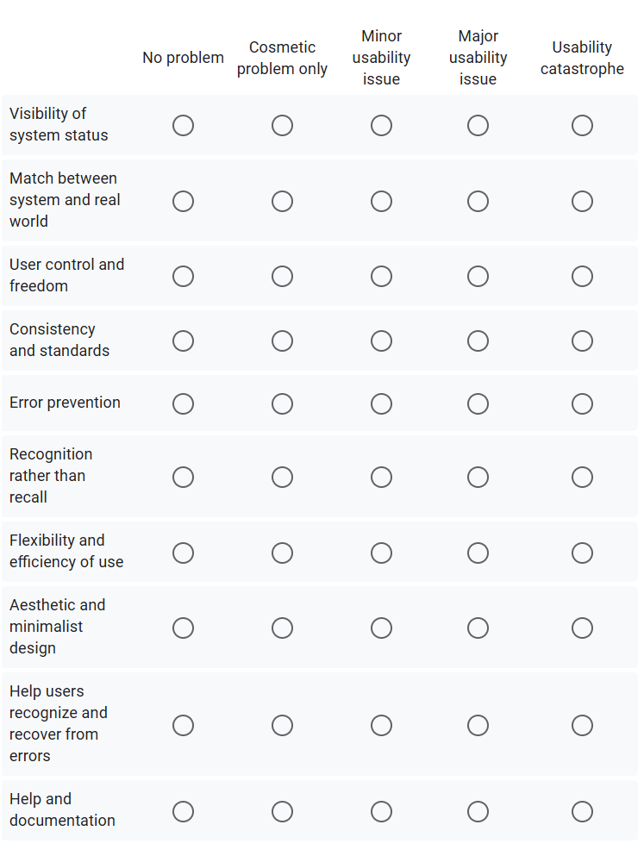

Response

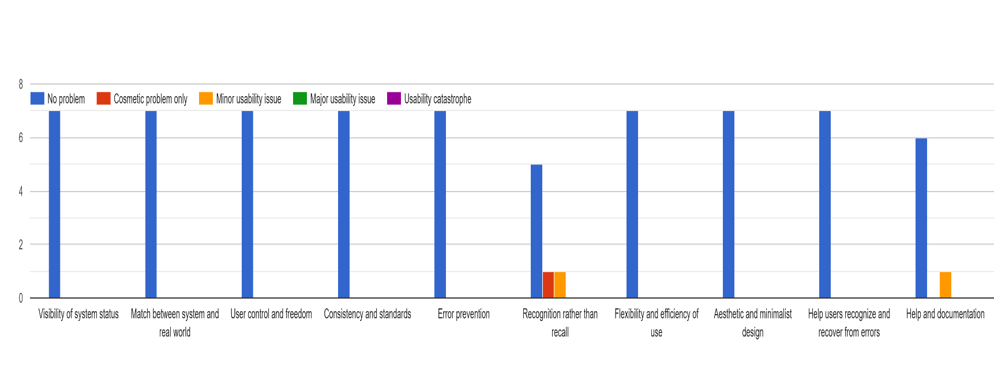

Most of the feedback was positive, and users had no problems. There were a few complaints about specific parts, such as some icons not being clear or missing help features. They were not big problems, but I will consider those points and try to improve those areas in later projects.

6. Feedback and Discussion

In my usability testing for Task 4, I got a suggestion: “I did not like it when I pressed the Things to Do button on the nav — it did not go to any page. I preferred it went to things I liked.” Since this is a prototype, I had not made a page for “Things to Do” — only the heart icon in the top right goes to the favourites. So, I changed the “Things to Do” button to “Favourites” so users can access their saved places more easily. Another suggestion came from Task 5: “The icon doesn’t have a tooltip to help recognize that it’s used for logging out.” So, I added tooltips to the top bar. Now, when you hover over each icon — like the notification, heart, or user icon — a small text lets the user know what it does before clicking.

At the end of my Google form, I asked users: “Do you have any suggestions for changes or improvements to the website?” I received three suggestions. The first one said: “I preferred the search box on the top bar to be in the middle and the logo on the left.” After reading this, I looked at a few websites and noticed that most have the logo on the left. It felt more natural and familiar, so I moved mine there, too. I also moved the search box to the centre. This helped because:

* It makes the search bar more noticeable
* It is easier to reach on both desktop and mobile

The second suggestion was “Tooltips to help people know what the icons mean and what they do.” I’ve already discussed this above—I added tooltips to the top bar so users can hover and see what each icon does before clicking. The third one said: “I would suggest that the search box is either centered or aligned to the left or right. Also, the navbar fonts would be better if they were larger.” I could not centre the search box entirely because I made it wider, which threw off the left and right spacing. However, for the second part of the suggestion, I increased the font size in the navigation bar to make it more readable, especially for accessibility.

Below are the responses I got and discussed above.

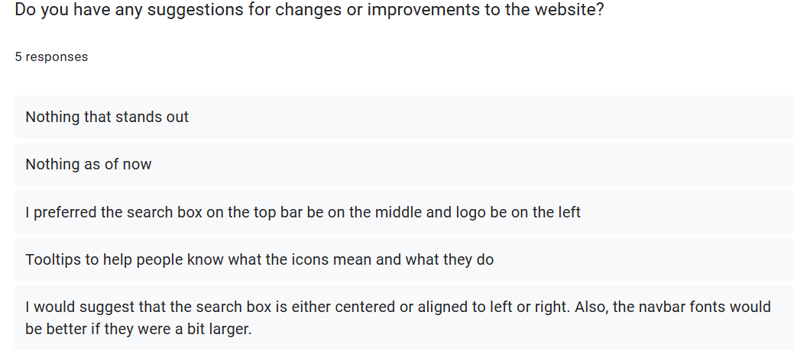

7. Conclusion

This website was made as a high-fidelity prototype for Leeds City. I wanted to build something tourists and people from Leeds could find helpful. I added functional features like sign-up and login, then focused on three main things—the calendar, the map, and the favourites system. I also considered accessibility while designing, so I avoided using tables, ensured the images had alt text, and kept the layout clean. Most of what I did was based on what I planned in CW1, but after getting feedback from people who tested it, I changed a few parts, which I have already explained earlier in this document. Some features, like the search and filters in the calendar or the save system with the heart button, were not working fully because those parts would need a real database behind them. For the future development of this project, we need to have an application that we can use for the database, endpoints, and more, so that the functions and advanced features work completely.

8. References

* All Icons images used from Flaticon. Retrieved from <https://www.flaticon.com>
* YouTube Video used on homepage. Retrieved from <https://www.youtube.com/watch?v=wrU1MbXpZn0&t=5s>
* Wikipedia. *Used for homepage text about Leeds.* Retrieved from <https://en.wikipedia.org/wiki/Leeds>
* Design.com**.** *Logo created for Leeds City*. Retrieved from <https://www.design.com/s/logo-maker>
* Some content, such as event names, place names, and descriptions used in the prototype cards, was generated using ChatGPT
* Leeds-List. *60 Things You Probably Don’t Know About Leeds*. Image used in prototype. Retrieved from <https://leeds-list.com/culture/60-things-you-probably-dont-know-about-leeds/>
* Google Maps. *Image, phone number, and address of Roundhay Park, Leeds.* Retrieved from <https://maps.app.goo.gl/s8PrVbSvqjs51xAk6>
* Google Maps. *Image, phone number, and address of Olive Tree Brasserie, Leeds.* Retrieved from <https://maps.app.goo.gl/Qvp9WHUhbG7PB7Xj7>
* Google Maps. *Image, phone number, and address of MathsCity, Leeds.* Retrieved from <https://maps.app.goo.gl/AjDuW5fSah8YkZSP8>
* Google Maps. *Image, phone number, and address of Trinity, Leeds.* Retrieved from <https://maps.app.goo.gl/SPdhnCHryddroLZg7>
* Google Maps. *Image, phone number, and address of Tower Square, Leeds.* Retrieved from [https://maps.app.goo.gl/KQw8qCaRqbP8M8uF9](https://maps.app.goo.gl/KQw8qCaRqbP8M8uF9%20)
* The following images used in this prototype were taken from the links below and are used for my high-fidelity design :

1. <https://images.unsplash.com/photo-1492684223066-81342ee5ff30>
2. <https://backstage.vn/storage/2020/05/shutterstock_538256848.jpg>
3. <https://www.eventsparadise.com/images/2024/03/20/Event-Planning.jpg>
4. <https://www.visitleeds.co.uk/wp-content/uploads/2022/12/Harewood-House-e1624026597471.jpeg>
5. <https://broganabroad.com/wp-content/uploads/2021/12/Leeds-Corn-Exchange.jpg.webp>
6. <https://upload.wikimedia.org/wikipedia/commons/1/1d/Leeds_Rathaus.jpg>
7. <https://static.vecteezy.com/system/resources/thumbnails/041/388/388/small/ai-generated-concert-crowd-enjoying-live-music-event-photo.jpg>
8. <https://marketing-cdn.tickettailor.com/ZgP1j7LRO5ile62O_HowdoyouhostasmallcommunityeventA10-stepguide%2CMiniflagsattheevent.jpg>
9. <https://thumbs.dreamstime.com/b/pink-purple-blue-decor-masquerade-mask-corporate-event-gala-dinner-119332614.jpg>
10. <https://t4.ftcdn.net/jpg/01/75/46/69/360_F_175466970_aRDdYku348o2ytRIJgeTuqychevhUe7u.jpg>